**Project**

**Honda website 2024**

Mizin Laurentiu Dumitru,

Student

**Summary**

1. **Short description**
2. **Web site structure**
   1. Navigation Bar
   2. Main page
   3. First screen video
   4. Corporate profile
   5. Business and Innovation
   6. Brand
   7. Sustainability
   8. Investors
   9. Newsroom
3. **World links**
   1. Office
   2. R&D
   3. Manufacturing Facilities
   4. Manufacturing (Components)
   5. Sales and Others
4. **Short description**

Welcome to the official Honda website! Honda is a globally recognized leader in the automotive and motorcycle industries, committed to enhancing mobility and improving the quality of life for people around the world. Our dedication to innovation, quality, and sustainability has established us as a trusted name in transportation.

Founded in 1948 by Soichiro Honda and Takeo Fujisawa, our journey began with a passion for engineering and a vision to create reliable and efficient motorcycles. What started as a small venture quickly transformed into a major player in the automotive sector. Today, Honda is one of the largest automobile manufacturers in the world, offering a diverse range of vehicles that cater to various needs and preferences.

At Honda, our mission is to create products that inspire joy and deliver value to our customers. We focus on developing advanced mobility solutions that prioritize safety, reliability, and environmental sustainability. Whether you’re interested in a car, motorcycle, or power equipment, we aim to exceed your expectations at every turn.

Quality is the cornerstone of our philosophy. Every vehicle and motorcycle we produce undergoes rigorous testing and quality assurance processes to ensure reliability and performance. Our commitment to excellence means that customers can trust Honda products to deliver an exceptional driving experience, mile after mile.

Innovation is embedded in our DNA. From our early days of manufacturing motorcycles to our current focus on electric and autonomous vehicles, we continually push the boundaries of technology. Our research and development teams work tirelessly to introduce cutting-edge features that enhance safety, efficiency, and user experience.

Environmental responsibility is a key priority for Honda. We are dedicated to reducing our carbon footprint and promoting sustainable practices throughout our operations. Our lineup includes a growing range of hybrid and electric vehicles designed to minimize environmental impact while still providing the performance and reliability Honda is known for.

Safety is paramount in our design and engineering processes. We incorporate advanced safety technologies, such as collision mitigation systems, adaptive cruise control, and lane-keeping assistance, into our vehicles. Our goal is to provide peace of mind for our customers, ensuring that every journey is as safe as possible.

Our diverse team of professionals drives Honda's success. Comprising skilled engineers, designers, and experts from various fields, our workforce is united by a shared passion for innovation and quality. We foster a collaborative environment that encourages creativity and the free exchange of ideas, leading to groundbreaking advancements in our products.

Honda has a rich history of community engagement and social responsibility. We believe in giving back to the communities where we operate. Through various initiatives, we support education, environmental conservation, and disaster relief efforts, demonstrating our commitment to making a positive impact on society.

Customer satisfaction is at the heart of everything we do. We strive to understand the needs and preferences of our customers and work diligently to ensure their experiences with Honda are exceptional. Our customer support teams are always ready to assist, providing prompt and helpful service to address any inquiries or concerns.

As we look to the future, Honda remains committed to leading the way in automotive innovation. We are exploring new technologies and partnerships that will shape the next generation of transportation. Our vision is to create a sustainable and connected world where mobility is accessible to all.

Thank you for visiting the Honda website. We invite you to explore our extensive lineup of vehicles, learn more about our innovative technologies, and discover our sustainability initiatives. If you have any questions or would like to learn more about our products, please don’t hesitate to reach out. Your feedback and engagement are invaluable to us as we continue our journey toward excellence.

1. **Tor**
2. Project Overview:

This TOR outlines the requirements and objectives for the website design project.

The project aims to create a user-friendly and visually appealing website for Honda

1. Objectives:
   1. **Showcase Product Lineup**: Provide comprehensive information about Honda's vehicles and motorcycles, including specifications, features, and pricing to help customers make informed purchasing decisions.
   2. **Enhance Customer Engagement**: Create an interactive platform where users can explore Honda products, engage with content, and connect with the brand through social media and community forums.
   3. **Promote Sustainability Initiatives**: Highlight Honda's commitment to environmental responsibility by showcasing eco-friendly vehicles, sustainable practices, and initiatives aimed at reducing carbon footprints.
   4. **Facilitate Easy Navigation**: Ensure the website is user-friendly, with intuitive navigation that allows visitors to quickly find information about products, services, and company values.
   5. **Provide Customer Support Resources**: Offer comprehensive support resources, including FAQs, manuals, service booking options, and contact information for customer service to enhance the ownership experience.
   6. **Highlight Innovation and Technology**: Showcase Honda’s advancements in automotive technology, including safety features, fuel efficiency, and electric vehicle offerings, to demonstrate leadership in the industry.
   7. **Educate on Safety Standards**: Inform visitors about Honda’s safety features and initiatives, emphasizing the brand’s commitment to providing safe and reliable vehicles.
   8. **Encourage Feedback and Communication**: Foster a two-way communication channel that invites feedback from customers and allows them to share their experiences, thereby improving customer satisfaction and brand loyalty.
2. Scope of Work:
   1. Define project goals and objectives.
   2. Identify target audience segments and user personas.
   3. Conduct a competitive analysis to understand industry standards and trends.
   4. Develop a sitemap and wireframes to outline website structure and navigation.
3. Deliverables:
   1. A detailed plan for content creation, including target keywords, content types, and tone of voice.
   2. Guidelines for written content, including vehicle descriptions, safety information, and brand messaging.
4. Our Commitment to Safety

Safety is a fundamental aspect of our design philosophy. We incorporate advanced safety features in all our vehicles, including collision mitigation systems, lane-keeping assistance, and more. Our goal is to provide peace of mind for our customers, ensuring that every journey is as safe as possible.

1. Budget:
   1. Project Management Software: $500
   2. Consultation and Strategy Development: $1,500
2. Our Team

Honda’s success is driven by our talented and diverse workforce. Our team comprises skilled engineers, designers, and professionals who are passionate about their work. We foster a culture of collaboration and creativity, encouraging our employees to innovate and take ownership of their projects. Together, we strive to make a positive impact on society through our products and initiatives

1. Our Commitment to Safety

Safety is a fundamental aspect of our design philosophy. We incorporate advanced safety features in all our vehicles, including collision mitigation systems, lane-keeping assistance, and more. Our goal is to provide peace of mind for our customers, ensuring that every journey is as safe as possible.

1. Get in Touch

We invite you to explore our website to learn more about our latest models, innovative technologies, and sustainability efforts. Whether you're interested in purchasing a new vehicle or simply want to learn more about our brand, we are here to help. If you have any questions or need assistance, please don’t hesitate to contact us. Your feedback is invaluable as we continue to strive for excellence!

1. **Requirements**

**UI/UX - Colors**

Main colors:

* Red
* Black
* White

**Browsers, devices and resolutions**

Browsers:

* Yandex
* Opera
* Google chrome

Devices:

* PC
* Mobile devices

Resolutions:

* PC
  + From full HD to 8K
* Mobile devices
  + Width from 300 to 600

1. **Web site structure**
   1. Navigation bar



* 1. Main page



* 1. First screen video

In this video is shown modern Honda cars are known for their reliability, fuel efficiency, and innovative technology. They feature sleek, aerodynamic designs with advanced safety systems like Honda Sensing, which includes collision mitigation braking and adaptive cruise control. The interiors are comfortable and packed with user-friendly infotainment systems that offer smartphone connectivity and intuitive controls. Honda's hybrid and electric models, such as the Accord Hybrid and the fully electric Prologue, highlight the company's commitment to eco-friendly driving. Overall, Honda cars offer a balanced blend of performance, practicality, and modern style.

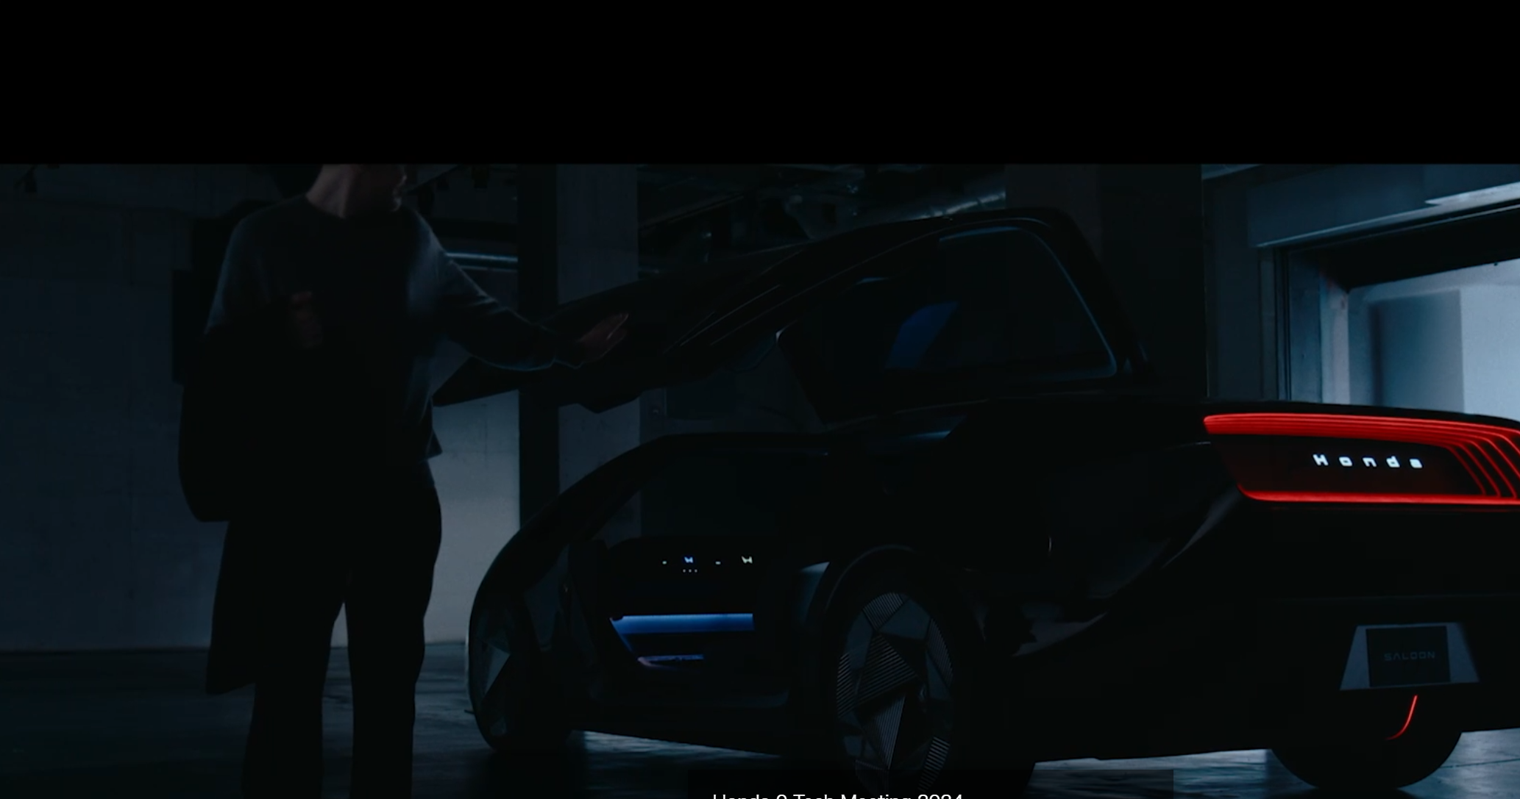

* 1. Corporate profile

The corporate profile on Honda's website highlights the company's mission to provide mobility solutions that enhance the quality of life. Honda emphasizes its commitment to innovation, sustainability, and customer satisfaction through the development of automobiles, motorcycles, and power products. The profile also showcases Honda's global operations, its focus on cutting-edge technology, and efforts to reduce environmental impact. Additionally, Honda's dedication to safety, corporate social responsibility, and creating a positive impact on communities is a central theme throughout its corporate identity.



* 1. Business and Innovation

The business and innovation section on Honda's website highlights the company's focus on creating advanced mobility solutions and expanding into new areas like robotics, energy management, and AI. Honda is committed to developing innovative products, such as electric and hydrogen-powered vehicles, that contribute to a more sustainable future. The company invests heavily in research and development to stay at the forefront of automotive technology, with a strong emphasis on safety, efficiency, and environmental impact. Additionally, Honda’s business approach emphasizes adaptability and customer-centric solutions to meet the evolving demands of a global market.



* 1. Brand

The brand section of Honda's website emphasizes its core values of innovation, reliability, and sustainability. Honda is dedicated to enhancing the mobility experience by designing products that are safe, efficient, and environmentally friendly. The brand's philosophy focuses on pushing boundaries through advanced technology and engineering, while maintaining a customer-first approach. Honda's global presence is reflected in its diverse range of vehicles, motorcycles, and power products, all designed to improve everyday life. Trust, quality, and forward-thinking innovation are central to the Honda brand identity.



* 1. Sustainability

The sustainability section of Honda's website outlines the company's commitment to reducing its environmental impact through innovative practices and green technologies. Honda focuses on creating eco-friendly products, including electric and hybrid vehicles, while striving to achieve carbon neutrality across its global operations. The company is dedicated to reducing emissions, conserving resources, and promoting recycling in both production and product life cycles. Honda also emphasizes responsible corporate practices, including energy efficiency and environmental stewardship, as part of its long-term vision for a more sustainable future.

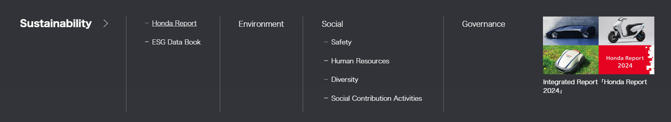

* 1. Investors

The investors section of Honda's website provides comprehensive information on the company’s financial performance, corporate governance, and business strategies. It highlights Honda's commitment to transparency and long-term growth, offering detailed reports, stock information, and updates on key financial indicators. The section also covers Honda’s investment in innovation and sustainability, which are seen as critical drivers for future growth. Investors can find insights into the company’s global operations, leadership, and strategic plans aimed at maintaining competitiveness in the evolving mobility industry.

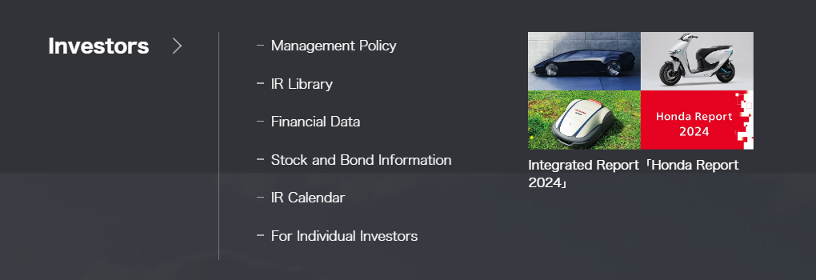

* 1. Newsroom

The newsroom section of Honda's website offers the latest updates on the company's news, events, and announcements. It features press releases, media resources, and statements covering Honda’s product launches, innovations, corporate milestones, and community initiatives. The newsroom also provides multimedia content such as videos and images for media use, as well as access to news on sustainability, partnerships, and industry developments. This section is a go-to source for journalists, stakeholders, and the public looking to stay informed about Honda’s activities and achievements.

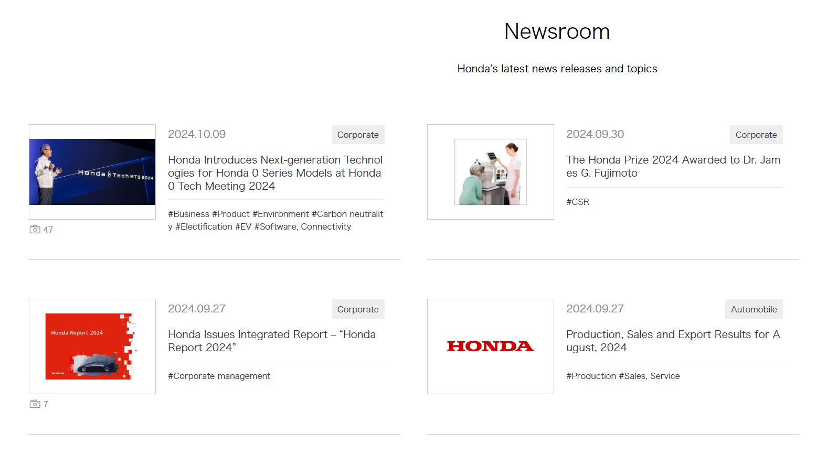

1. **World links**
   1. Main page

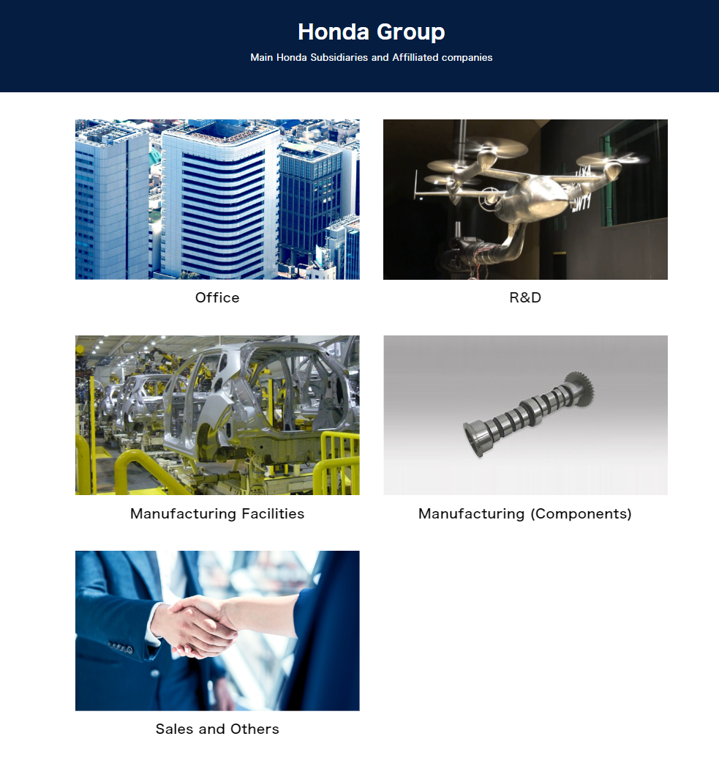

* 1. Office

The office section of Honda's website provides information about the company’s global and regional headquarters, as well as its various operational offices around the world. It highlights Honda’s extensive international presence, supporting its global business in automotive, motorcycle, and power products. The section typically includes contact details, addresses, and sometimes key functions of each office. This area is useful for customers, investors, and partners seeking direct communication with Honda's corporate offices or local branches.

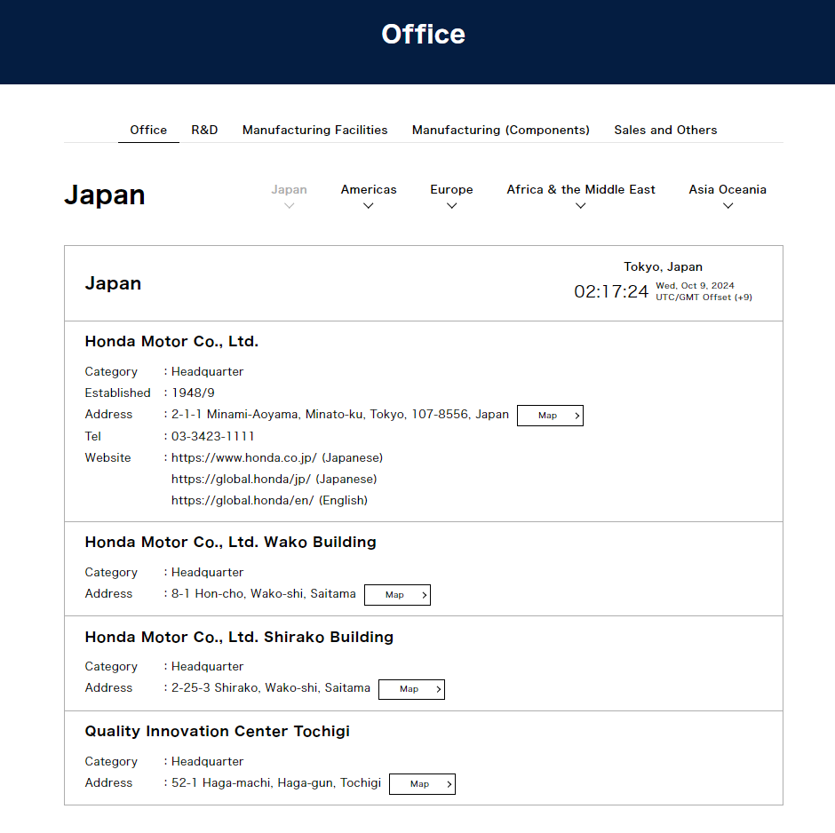

* 1. R&D

The R&D section of Honda's website highlights the company’s dedication to innovation and technological advancement. Honda's research and development efforts focus on creating next-generation mobility solutions, including electric vehicles, autonomous driving technologies, and robotics. The section showcases Honda's commitment to sustainability, safety, and performance through cutting-edge engineering. It also emphasizes Honda’s global network of R&D centers that drive innovation in product design, energy efficiency, and eco-friendly technologies, ensuring the company stays at the forefront of the mobility industry.

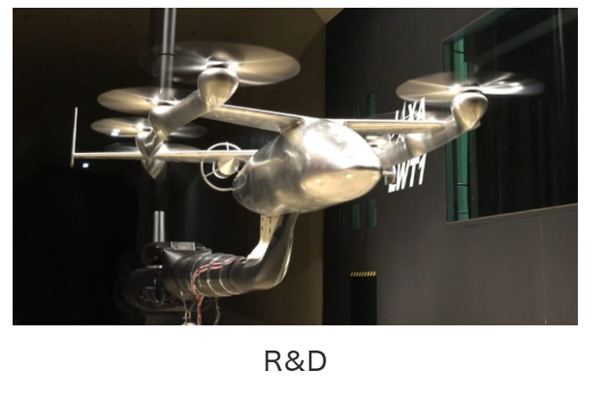

* 1. Manufacturing Facilities

The manufacturing facilities section of Honda's website highlights the company's global network of production plants that produce automobiles, motorcycles, and power products. These facilities are known for their high standards of quality, efficiency, and sustainability. Honda emphasizes its commitment to environmentally responsible manufacturing processes, including reducing waste and energy consumption. The section also showcases the use of advanced technologies, automation, and flexible production lines to meet the demands of different markets. Honda's manufacturing approach ensures that its products are made with precision, durability, and environmental consciousness.

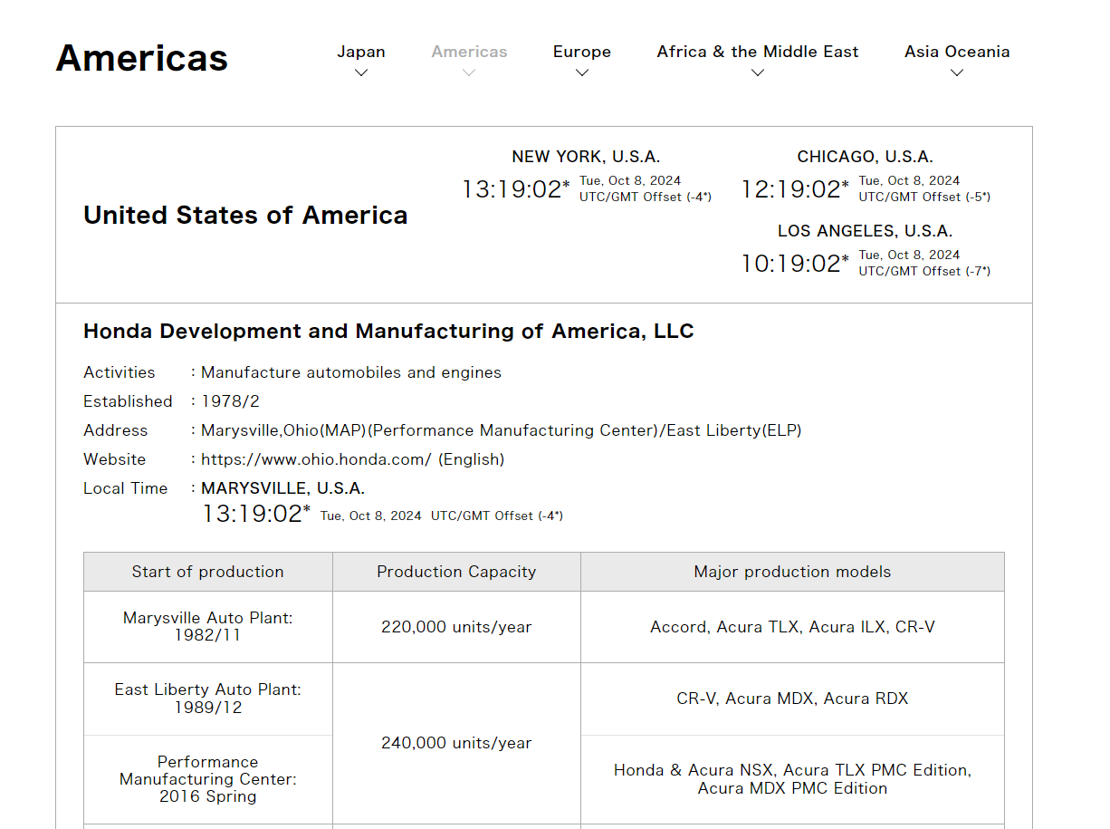

* 1. Manufacturing (Components)

The manufacturing (components) facilities section of Honda's website details the company’s extensive network of plants dedicated to producing high-quality automotive and motorcycle components. These facilities focus on precision engineering and advanced manufacturing techniques to ensure reliability and performance in every part. Honda emphasizes its commitment to sustainability by implementing eco-friendly practices and reducing waste throughout the production process. The section highlights the integration of innovative technologies and automation, which enhance efficiency and quality control. This approach allows Honda to maintain a robust supply chain and support its diverse range of vehicles and products.

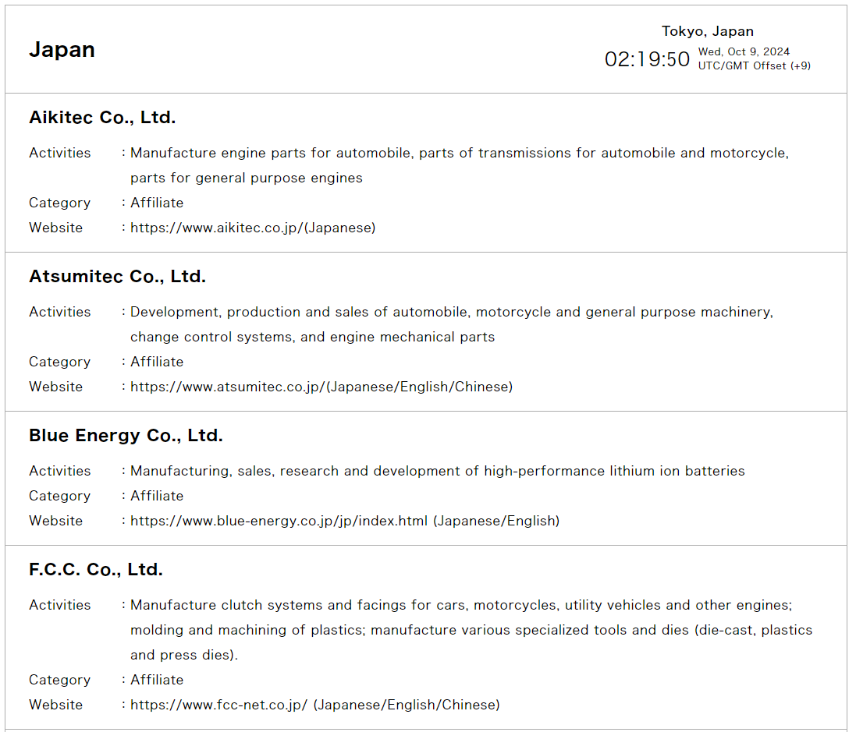

* 1. Sales and Others

The sales and offers facilities section of Honda's website provides customers with information about purchasing options, promotions, and financing plans for Honda vehicles. This section highlights current offers, special deals, and incentives available to buyers, making it easier for them to find the best value. Additionally, it features tools for comparing models, accessing pricing details, and locating authorized dealerships. Honda emphasizes a customer-centric approach, aiming to enhance the purchasing experience with transparent information and support throughout the sales process.

